STEP1- Import Table

**CREATE TABLE pizza_sales(**

**pizza_id int,**

**order_id int,**

**pizza_name_id varchar(60),**

**quantity tinyint,**

**order_date date,**

**order_time time,**

**unit_price float,**

**tota_price float,**

**pizza_size varchar(20),**

**pizza_category varchar(60),**

**pizza_ingredients varchar(255),**

**pizza_name varchar(100));**

**Import Values By Using Location:**

STEP2-FIND KPI’S

1. **Total Revenue:**

**SELECT ROUND(SUM(tota_price)) as "Total_Revenue"**

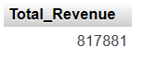**FROM pizza_sales;**

1. **Average Order Value**

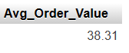**SELECT ROUND(SUM(tota_price)/COUNT(DISTINCT order_id),2) as "Avg_Order_Value" FROM pizza_sales**

**3. Total Pizzas Sold**

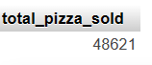**SELECT COUNT(quantity) as "total_pizza_sold"**

**4. Total Orders**

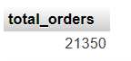**SELECT COUNT(DISTINCT order_id) as "total_orders" FROM**

**pizza_sales**

**5. Average Pizzas Per Order**

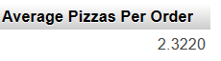**SELECT SUM(quantity)/COUNT(DISTINCT order_id) as "Average Pizzas Per Order"**

**FROM pizza_sales**

STEP 3. FIND TREND

1. **Daily Trend for Total Orders**

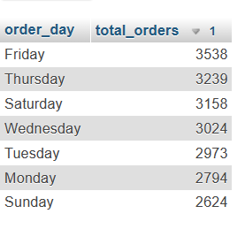**SELECT DAYNAME(order_date) as 'order_day', COUNT(DISTINCT order_id) as "total_orders"**

**FROM pizza_sales**

**GROUP BY DAYNAME(order_date)**

**ORDER BY total_orders DESC**

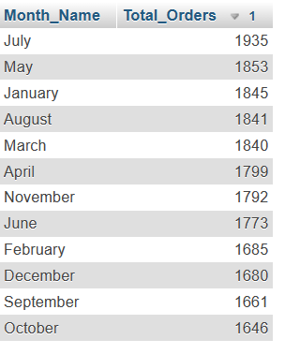

1. **Monthly Trend for Orders**

**select MONTHNAME( order_date) as Month_Name, COUNT(DISTINCT order_id) as Total_Orders**

**from pizza_sales**

**GROUP BY Month_Name**

**ORDER BY Total_Orders DESC**

1. **% of Sales by Pizza Category**

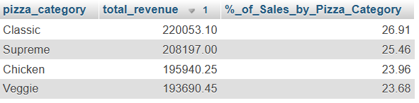**SELECT pizza_category, (ROUND(SUM(tota_price),2)) as "total_revenue", (ROUND(SUM(tota_price)*100 /(SELECT SUM(tota_price) from pizza_sales),2)) as '%_of_Sales_by_Pizza_Category'**

**FROM pizza_sales**

**GROUP BY pizza_category**

**ORDER BY total_revenue DESC**

1. **% of Sales by Pizza Size**

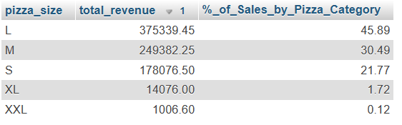**SELECT pizza_size, (ROUND(SUM(tota_price),2)) as "total_revenue", (ROUND(SUM(tota_price)*100 /(SELECT SUM(tota_price) from pizza_sales),2)) as '%_of_Sales_by_Pizza_Category'**

**FROM pizza_sales**

**GROUP BY pizza_size**

**ORDER BY total_revenue DESC**

**5. Total Pizzas Sold by Pizza Category**

**SELECT pizza_category,SUM(quantity) as 'total_quantity_sold'**

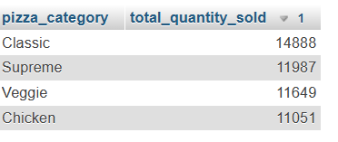**FROM pizza_sales**

**GROUP BY pizza_category**

**ORDER BY total_quantity_sold DESC**

**6.Top 5 Pizzas by Revenue**

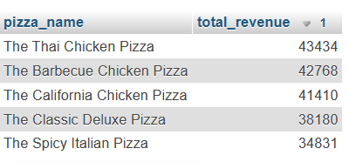**SELECT pizza_name, ROUND(SUM(tota_price)) as "total_revenue"**

**FROM pizza_sales**

**GROUP BY pizza_name**

**ORDER BY total_revenue DESC LIMIT 5**

**7.Bottom 5 Pizzas by Revenue**

**SELECT pizza_name, ROUND(SUM(tota_price)) as "total_revenue"**

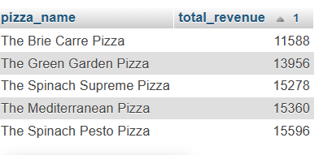 **FROM pizza_sales**

**GROUP BY pizza_name**

**ORDER BY total_revenue LIMIT 5**

**8. Top 5 Pizzas by Quantity**

**SELECT pizza_name, ROUND(SUM(quantity)) as "total_quantity"**

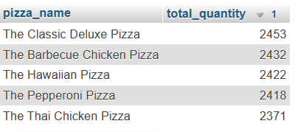**FROM pizza_sales**

**GROUP BY pizza_name**

**ORDER BY total_quantity DESC LIMIT 5**

**9. Bottom 5 Pizzas by Quantity**

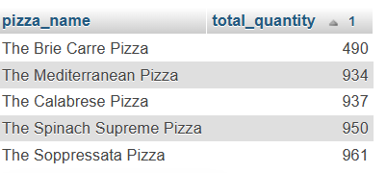**SELECT pizza_name, ROUND(SUM(quantity)) as "total_quantity"**

**FROM pizza_sales**

**GROUP BY pizza_name**

**ORDER BY total_quantity LIMIT 5**

**10.Top 5 Pizzas by Total Orders**

**SELECT pizza_name, COUNT(DISTINCT order_id) as "total_order"**

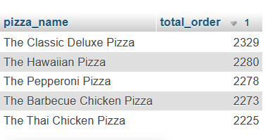**FROM pizza_sales**

**GROUP BY pizza_name**

**ORDER BY total_order DESC LIMIT 5**

**11.Bottom 5 Pizzas by Total Orders**

**SELECT pizza_name, COUNT(DISTINCT order_id) as "total_order"**

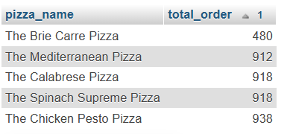**FROM pizza_sales**

**GROUP BY pizza_name**

**ORDER BY total_order LIMIT 5**

***NOTE***

**If you want to apply the pizza_category or pizza_size filters to the above queries you can use WHERE clause. Follow some of below examples**

**SELECT Top 5 pizza_name, COUNT(DISTINCT order_id) AS Total_Orders**

**FROM pizza_sales**

**WHERE pizza_category = 'Classic'**

**GROUP BY pizza_name**

**ORDER BY Total_Orders ASC**